International Day of Action
2nd Anniversary of
the Invasion of Iraq
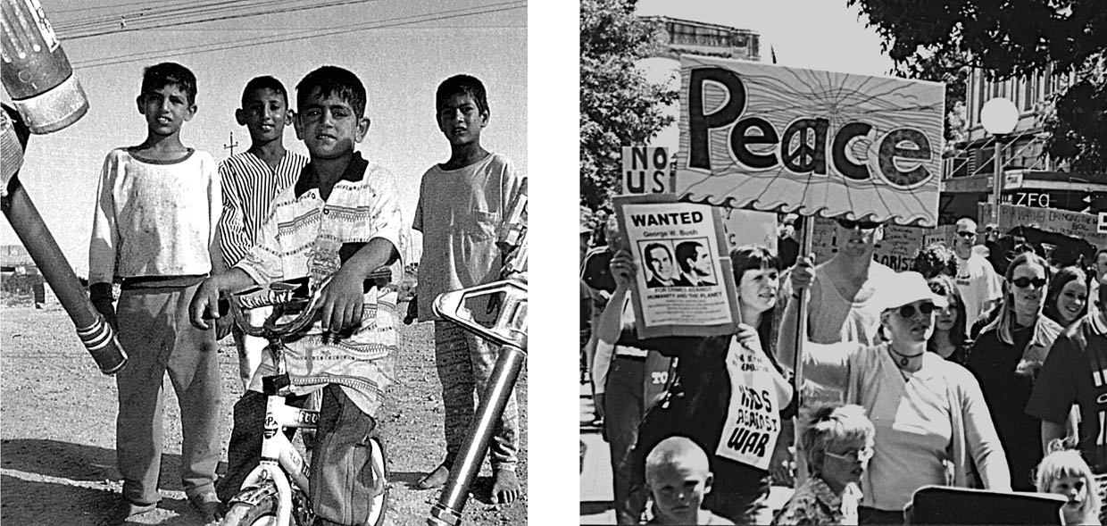

Saturday March 19
Rally and ‘Die-in’ to Commemorate the 100,000 Iraqis Killed
Assemble 12 noon Cathedral Square
 | Peace Action Network
Contact: Larry 337 0118 or Darren 379 0005 peaceactionnetwork@hotmail.com
For info on Iraq War and related issues see: http://www.nuclearfreenz.org.nz/

